Task N1 : When asked about providing scenarios in which an attacker used sniffing or spoofing, the first example that comes to mind is the ‘2010 Firesheep tool’ that was discussed in a previous class. The sniff involved attackers on public wifi sniffing unencrypted session cookies putting accounts at risk. The resolution to this was found to be using an encrypted connection (https > http) and optionally enabling a vpn for public wifi. A spoofing attack example would be the ‘2015 Ubiquiti Network attack’ where attackers spoofed fake executive emails to authorize almost fifty million dollars in fraud wire transfers. The resolution to this was found to be using an email authentication or implementing 2FA+ for any financial transactions.

Task N2 : *screenshots*
- capture only the ICMP packet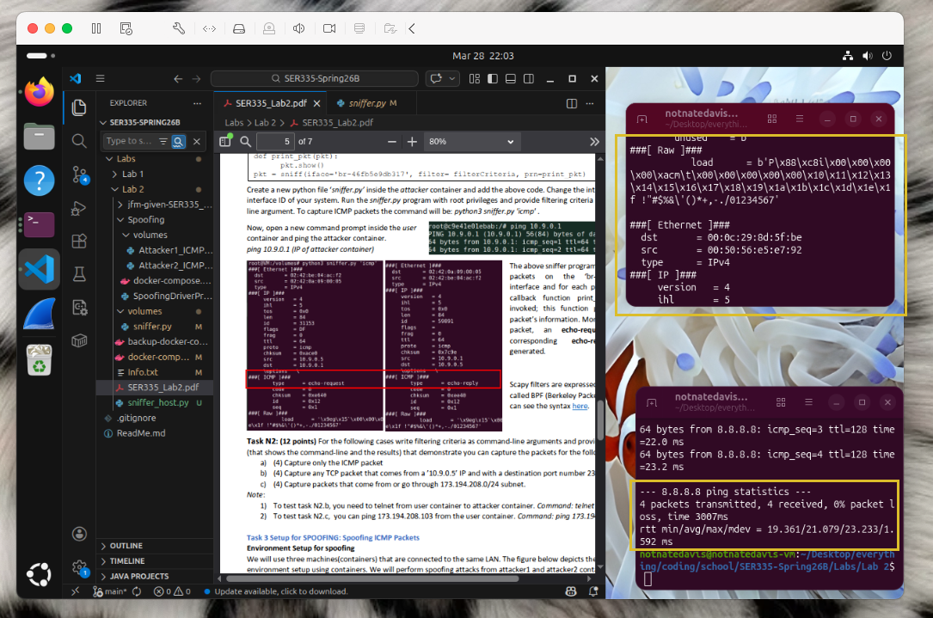
- capture any TCP packet from ‘10.9.0.5’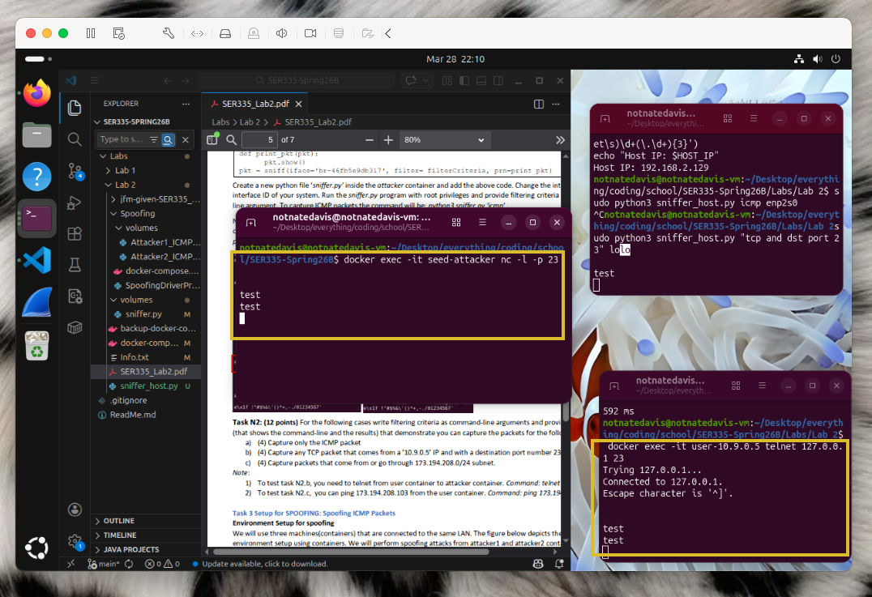
- capture packets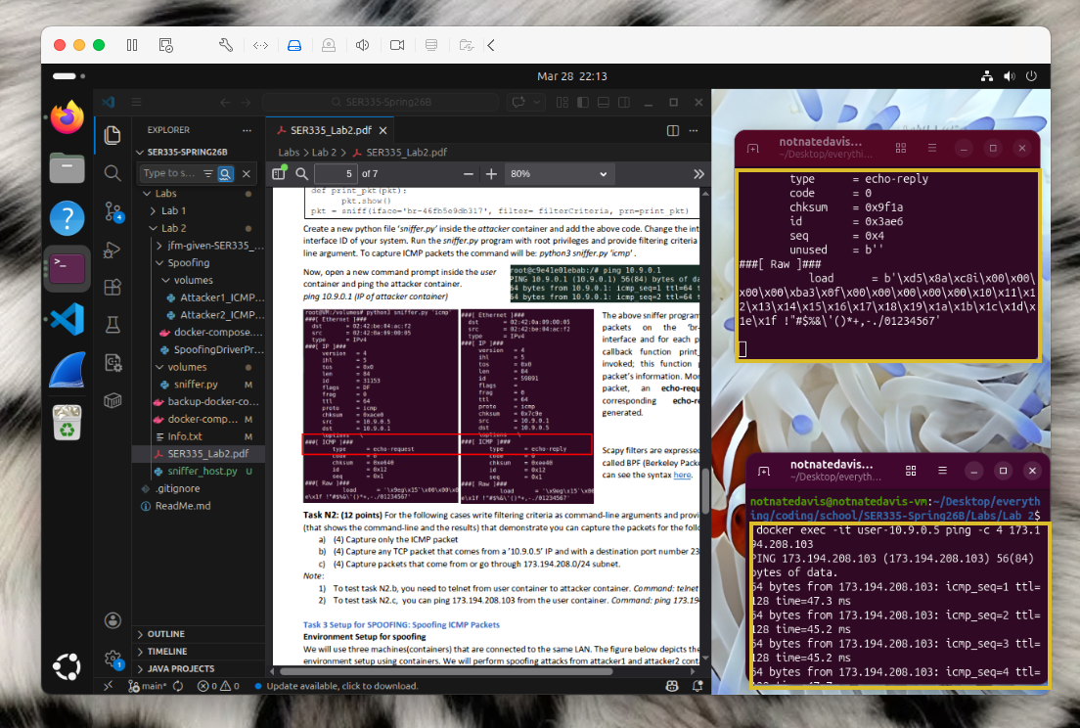

Task N3 :
Ip spoofing is the creation of ip packets with fake source address with the intent of hiding or masking the machine. In this specific Lab 2 the attacker program sniffs capturing all ICMP packets on the network interface and then spoofs an Echo Reply on any activity.

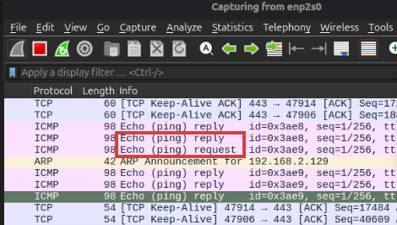

Task N4 :
b) screenshot Wireshark
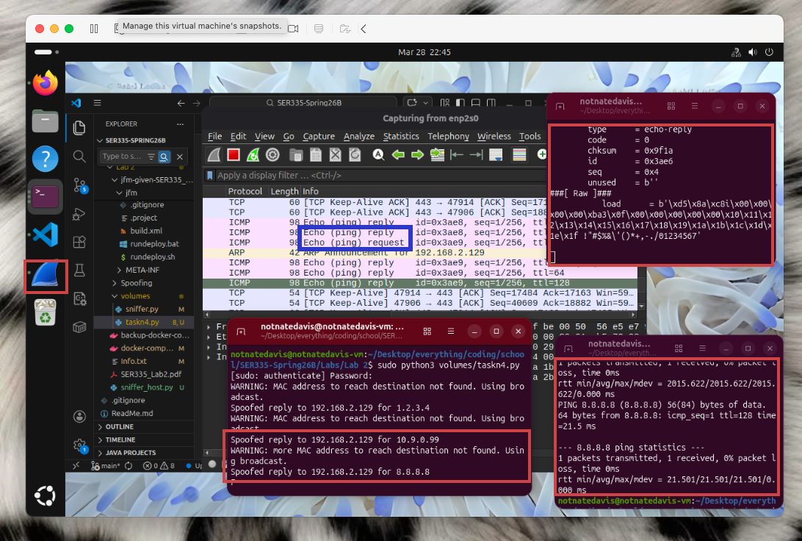
c) Pinging the following 3 IP addresses from the user container successfully spoofs the presence of any pinged host from the attacker. Despite (1.2.3.4) and (10.9.0.99) having no real host the attacker can still spoof the destination.

